UNIT 6 - SOFTWARE QUALITY ASSURANCE AND SECURITY
Software Quality Definition:
Software Quality is defined as the conformance to explicitly state functional and performance requirements, explicitly documented development standards, and inherent characteristics that are expected of all professionally developed software.

Software Quality is conformance to:
explicitly stated functional and performance requirements,
explicitly documented development standards,
implicit characteristics that are expected of all professionally developed
software.
Quality defines to any measurable characteristics such as correctness, maintainability, portability, testability, usability, reliability, efficiency, integrity, reusability, and interoperability.

Quality Control: Quality Control involves a series of inspections, reviews, and tests used throughout the software process to ensure each work product meets the requirements place upon it. Quality control includes a feedback loop to the process that created the work product.
Quality Assurance: Quality Assurance is the preventive set of activities that provide greater confidence that the project will be completed successfully.
Quality Assurance focuses on how the engineering and management activity will be done?
As anyone is interested in the quality of the final product, it should be assured that we are building the right product.
It can be assured only when we do inspection & review of intermediate products, if there are any bugs, then it is debugged. This quality can be enhanced.

Importance of Quality
We would expect the quality to be a concern of all producers of goods and services. However, the distinctive characteristics of software and in particular its intangibility and complexity, make special demands.
Increasing criticality of software: The final customer or user is naturally concerned about the general quality of software, especially its reliability. This is increasing in the case as organizations become more dependent on their computer systems and software is used more and more in safety-critical areas. For example, to control aircraft.
The intangibility of software: This makes it challenging to know that a particular task in a project has been completed satisfactorily. The results of these tasks can be made tangible by demanding that the developers produce 'deliverables' that can be examined for quality.
Accumulating errors during software development: As computer system development is made up of several steps where the output from one level is input to the next, the errors in the earlier ?deliverables? will be added to those in the later stages leading to accumulated determinable effects. In general the later in a project that an error is found, the more expensive it will be to fix. In addition, because the number of errors in the system is unknown, the debugging phases of a project are particularly challenging to control.

Software Quality Assurance
Software quality assurance is a planned and systematic plan of all actions necessary to provide adequate confidence that an item or product conforms to establish technical requirements.
A set of activities designed to calculate the process by which the products are developed or manufactured.

SQA Encompasses
- A quality management approach
- Effective Software engineering technology (methods and tools)
- Formal technical reviews that are tested throughout the software process
- A multitier testing strategy
- Control of software documentation and the changes made to it.
- A procedure to ensure compliances with software development standards
- Measuring and reporting mechanisms.

SQA Activities
Software quality assurance is composed of a variety of functions associated with two different constituencies ? the software engineers who do technical work and an SQA group that has responsibility for quality assurance planning, record keeping, analysis, and reporting.

Following activities are performed by an independent SQA group:
- Prepares an SQA plan for a project: The program is developed during project planning and is reviewed by all stakeholders. The plan governs quality assurance activities performed by the software engineering team and the SQA group. The plan identifies calculation to be performed, audits and reviews to be performed, standards that apply to the project, techniques for error reporting and tracking, documents to be produced by the SQA team, and amount of feedback provided to the software project team.
- Participates in the development of the project's software process description: The software team selects a process for the work to be performed. The SQA group reviews the process description for compliance with organizational policy, internal software standards, externally imposed standards (e.g. ISO-9001), and other parts of the software project plan.
- Reviews software engineering activities to verify compliance with the defined software process: The SQA group identifies, reports, and tracks deviations from the process and verifies that corrections have been made.
- Audits designated software work products to verify compliance with those defined as a part of the software process: The SQA group reviews selected work products, identifies, documents and tracks deviations, verify that corrections have been made, and periodically reports the results of its work to the project manager.
- Ensures that deviations in software work and work products are documented and handled according to a documented procedure: Deviations may be encountered in the project method, process description, applicable standards, or technical work products.
- Records any noncompliance and reports to senior management: Non- compliance items are tracked until they are resolved.

Quality Assurance v/s Quality control
Quality Assurance | Quality Control
Quality Assurance (QA) is the set of actions including facilitation, training, measurement, and analysis needed to provide adequate confidence that processes are established and continuously improved to produce products or services that conform to specifications and are fit for use. | Quality Control (QC) is described as the processes and methods used to compare product quality to requirements and applicable standards, and the actions are taken when a nonconformance is detected.
QA is an activity that establishes and calculates the processes that produce the product. If there is no process, there is no role for QA. | QC is an activity that demonstrates whether or not the product produced met standards.
QA helps establish process | QC relates to a particular product or service
QA sets up a measurement program to evaluate processes | QC verified whether particular attributes exist, or do not exist, in a explicit product or service.
QA identifies weakness in processes and improves them. | QC identifies defects for the primary goals of correcting errors.
Quality Assurance is a managerial tool. | Quality Control is a corrective tool.
Verification is an example of QA. | Validation is an example of QC.

SQA Implementation in different phases
Quality assurance will be implemented through all the software life cycles of the tool’s development process, until the release of the software product. The following are the quality assurance tasks for each phase of the software development:
Requirements phase: When the SRS is being developed, the developer has to ensure that it elucidates the proposed functionality of the product and to keep refining the SRS until the requirements are clearly stated and understood.
Specification and Design phase: Due to the great importance for accuracy and completeness in these documents, weekly reviews shall be conducted between the developer and the professor to identify any defects and rectify them.
Implementation phase: The developer shall do code reviews when the construction phase of the Tool begins.
Software testing phase: The developer shall test each case. The final product shall be verified with the functionality of the software as specified in the Software Requirements Specification (SRS) for the Tool.
Through all these phases of the software development, the following shall also be conducted to improve the software quality:
- · Develop and generate SQAP: Generate a finalized SQAP plan
- · Communication and Feedback: The developer is encouraged to freely express disagreements, suggestions and opinions about all aspects of the weekly process of software development.
- · Internal audits and evaluations: The Major professor and the committee are expected to do auditions and evaluations at the end of each phase in the project.

Quality Evaluation Standards:

Six Sigma
Six Sigma is the process of improving the quality of the output by identifying and eliminating the cause of defects and reduce variability in manufacturing and business processes. The maturity of a manufacturing process can be defined by a sigma rating indicating its percentage of defect-free products it creates. A six sigma method is one in which 99.99966% of all the opportunities to produce some features of a component are statistically expected to be free of defects (3.4 defective features per million opportunities).
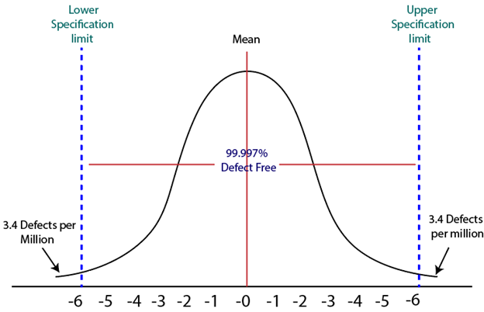

History of Six Sigma
Six-Sigma is a set of methods and tools for process improvement. It was introduced by Engineer ,Sir Bill Smith while working at Motorola in 1986. In the 1980s, Motorola was developing Quasar televisions which were famous, but the time there was lots of defects which came up on that due to picture quality and sound variations.
By using the same raw material, machinery and workforce a Japanese form took over Quasar television production, and within a few months, they produce Quasar TV's sets which have fewer errors. This was obtained by improving management techniques.
Six Sigma was adopted by Bob Galvin, the CEO of Motorola in 1986 and registered as a Motorola Trademark on December 28, 1993, then it became a quality leader.

Characteristics of Six Sigma
The Characteristics of Six Sigma are as follows:
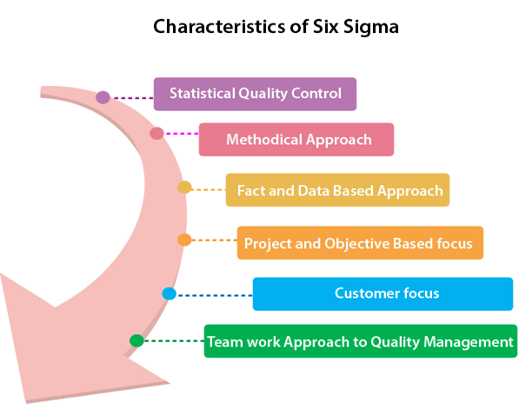
- Statistical Quality Control: Six Sigma is derived from the Greek Letter σ (Sigma) from the Greek alphabet, which is used to denote Standard Deviation in statistics. Standard Deviation is used to measure variance, which is an essential tool for measuring non-conformance as far as the quality of output is concerned.
- Methodical Approach: The Six Sigma is not a merely quality improvement strategy in theory, as it features a well defined systematic approach of application in DMAIC and DMADV which can be used to improve the quality of production. DMAIC is an acronym for Design-Measure- Analyze-Improve-Control. The alternative method DMADV stands for Design-Measure- Analyze-Design-Verify.
- Fact and Data-Based Approach: The statistical and methodical aspect of Six Sigma shows the scientific basis of the technique. This accentuates essential elements of the Six Sigma that is a fact and data-based.
- Project and Objective-Based Focus: The Six Sigma process is implemented for an organization's project tailored to its specification and requirements. The process is flexed to suits the requirements and conditions in which the projects are operating to get the best results.
- Customer Focus: The customer focus is fundamental to the Six Sigma approach. The quality improvement and control standards are based on specific customer requirements.
- Teamwork Approach to Quality Management: The Six Sigma process requires organizations to get organized when it comes to controlling and improving quality. Six Sigma involving a lot of training depending on the role of an individual in the Quality Management team.

Six Sigma Methodologies
Six Sigma projects follow two project methodologies:
- DMAIC
- DMADV

DMAIC
It specifies a data-driven quality strategy for improving processes. This methodology is used to enhance an existing business process.
The DMAIC project methodology has five phases:
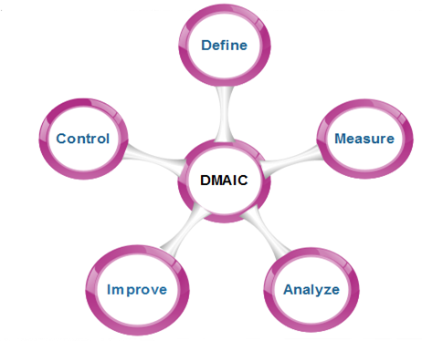
- Define: It covers the process mapping and flow-charting, project charter development, problem-solving tools, and so-called 7-M tools.
- Measure: It includes the principles of measurement, continuous and discrete data, and scales of measurement, an overview of the principle of variations and repeatability and reproducibility (RR) studies for continuous and discrete data.
- Analyze: It covers establishing a process baseline, how to determine process improvement goals, knowledge discovery, including descriptive and exploratory data analysis and data mining tools, the basic principle of Statistical Process Control (SPC), specialized control charts, process capability analysis, correlation and regression analysis, analysis of categorical data, and non-parametric statistical methods.
- Improve: It covers project management, risk assessment, process simulation, and design of experiments (DOE), robust design concepts, and process optimization.
- Control: It covers process control planning, using SPC for operational control and PRE-Control.

DMADV
It specifies a data-driven quality strategy for designing products and processes. This method is used to create new product designs or process designs in such a way that it results in a more predictable, mature, and detect free performance.
The DMADV project methodology has five phases:
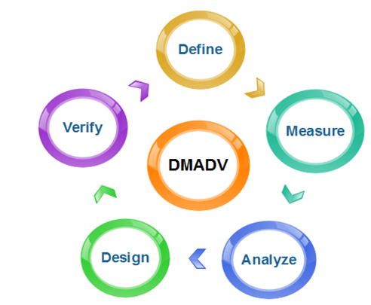
- Define: It defines the problem or project goal that needs to be addressed.
- Measure: It measures and determines the customer's needs and specifications.
- Analyze: It analyzes the process to meet customer needs.
- Design: It can design a process that will meet customer needs.
- Verify: It can verify the design performance and ability to meet customer needs.

Capability Maturity Model Integration (CMMI)
Capability Maturity Model Integration (CMMI) is a successor of CMM and is a more evolved model that incorporates best components of individual disciplines of CMM like Software CMM, Systems Engineering CMM, People CMM, etc. Since CMM is a reference model of matured practices in a specific discipline, so it becomes difficult to integrate these disciplines as per the requirements. This is why CMMI is used as it allows the integration of multiple disciplines as and when needed.

Objectives of CMMI :
- Fulfilling customer needs and expectations.
- Value creation for investors/stockholders.
- Market growth is increased.
- Improved quality of products and services.
- Enhanced reputation in Industry.
CMMI Representation – Staged and Continuous :
A representation allows an organization to pursue a different set of improvement objectives. There are two representations for CMMI :
- Staged Representation :
  - uses a pre-defined set of process areas to define improvement path.

  - provides a sequence of improvements, where each part in the sequence serves as a foundation for the next.
  - an improved path is defined by maturity level.
  - maturity level describes the maturity of processes in organization.
  - Staged CMMI representation allows comparison between different organizations for multiple maturity levels.
- Continuous Representation :
  - allows selection of specific process areas.
  - uses capability levels that measures improvement of an individual process area.
  - Continuous CMMI representation allows comparison between different organizations on a process-area-by-process-area basis.
  - allows organizations to select processes which require more improvement.
  - In this representation, order of improvement of various processes can be selected which allows the organizations to meet their objectives and eliminate risks.
CMMI Model – Maturity Levels :
In CMMI with staged representation, there are five maturity levels described as follows :
- Maturity level 1 : Initial
  - processes are poorly managed or controlled.
  - unpredictable outcomes of processes involved.
  - ad hoc and chaotic approach used.
  - No KPAs (Key Process Areas) defined.
  - Lowest quality and highest risk.
- Maturity level 2 : Managed
  - requirements are managed.
  - processes are planned and controlled.
  - projects are managed and implemented according to their documented plans.
  - This risk involved is lower than Initial level, but still exists.
  - Quality is better than Initial level.
- Maturity level 3 : Defined
  - processes are well characterized and described using standards, proper procedures, and methods, tools, etc.
  - Medium quality and medium risk involved.
  - Focus is process standardization.
- Maturity level 4 : Quantitatively managed
  - quantitative objectives for process performance and quality are set.
  - quantitative objectives are based on customer requirements, organization needs, etc.
  - process performance measures are analyzed quantitatively.
  - higher quality of processes is achieved.
  - lower risk
- Maturity level 5 : Optimizing
  - continuous improvement in processes and their performance.
  - improvement has to be both incremental and innovative.
  - highest quality of processes.
  - lowest risk in processes and their performance.
CMMI Model – Capability Levels
A capability level includes relevant specific and generic practices for a specific process area that can improve the organization’s processes associated with that process area. For CMMI models with continuous representation, there are six capability levels as described below :
- Capability level 0 : Incomplete
  - incomplete process – partially or not performed.
  - one or more specific goals of process area are not met.
  - No generic goals are specified for this level.
  - this capability level is same as maturity level 1.
- Capability level 1 : Performed
  - process performance may not be stable.
  - objectives of quality, cost and schedule may not be met.
  - a capability level 1 process is expected to perform all specific and generic practices for this level.
  - only a start-step for process improvement.
- Capability level 2 : Managed
  - process is planned, monitored and controlled.
  - managing the process by ensuring that objectives are achieved.
  - objectives are both model and other including cost, quality, schedule.
  - actively managing processing with the help of metrics.
- Capability level 3 : Defined
  - a defined process is managed and meets the organization’s set of guidelines and standards.
  - focus is process standardization.
- Capability level 4 : Quantitatively Managed
  - process is controlled using statistical and quantitative techniques.
  - process performance and quality is understood in statistical terms and metrics.
  - quantitative objectives for process quality and performance are established.
- Capability level 5 : Optimizing
  - focuses on continually improving process performance.
  - performance is improved in both ways – incremental and innovation.
  - emphasizes on studying the performance results across the organization to ensure that common causes or issues are identified and fixed.

https://www.investopedia.com/terms/i/iso-9000.asp

